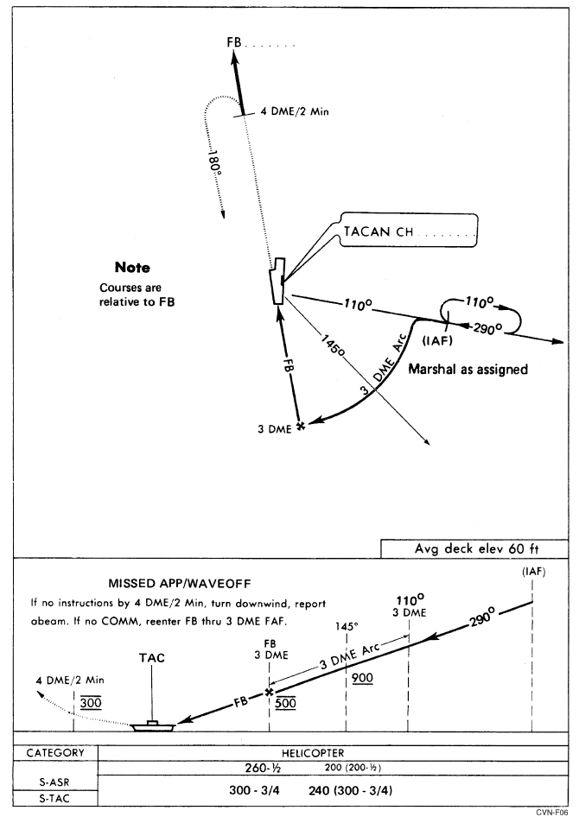

**Approach Chart CV-3 TACAN Overhead (Jet and Turboprop)**